

School Of Engineering and Technology

Computer Science and Engineering Department

Navrachana University, Vadodara

Fourth Year B.Tech CSE (Semester 7)

Academic Year 2024-2025

Augmented & Virtual Reality (ARVR)

Course In-Charge: Professor Darshan Parmar

**Topic: Paper Throw VR Game**

Student Name: Yash Joshi (21124046)

Date: 26/10/24

**Task 1: Set Up Your Unity Project & Configure the VR Environment**

* I named my project as VR_assignment because im not sure that which game should I make.

Select OpenXR in PC.

* After this open OpenXR from the left panel.  
  and in Enable interaction profile select the below 4 profiles for interaction.

* After installing all the necessary tools and configuration I decided to make a Paper ball throwing game.
* In this game I have to grab paper balls and throw It into dustbin from an distance in one class room.  
  after the installation of XR interaction toolkit I imported stater assets from it.

* I install this stater pack because I need all the inbuild assets for movements of hand all making VR game.
* After this I add XR Origin (xr rig)

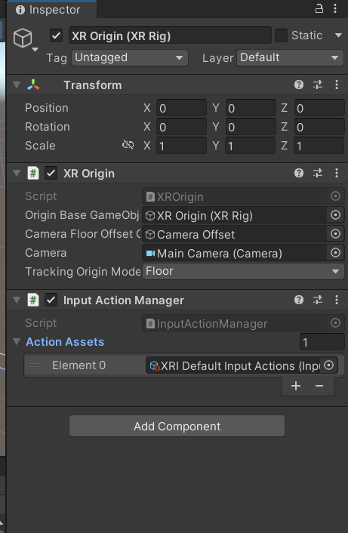

* It contains camera offset. In the camera offset there are three components main camera, left hand controller and right hand controller.
* Set XR origin to the 0, 0, 0 position and inside that set the position of camera offset also 0, 0, 0.
* In Camera Offset there are two controllers

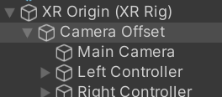

* Select both and add interaction to both hand in XR Controller in inspector menu

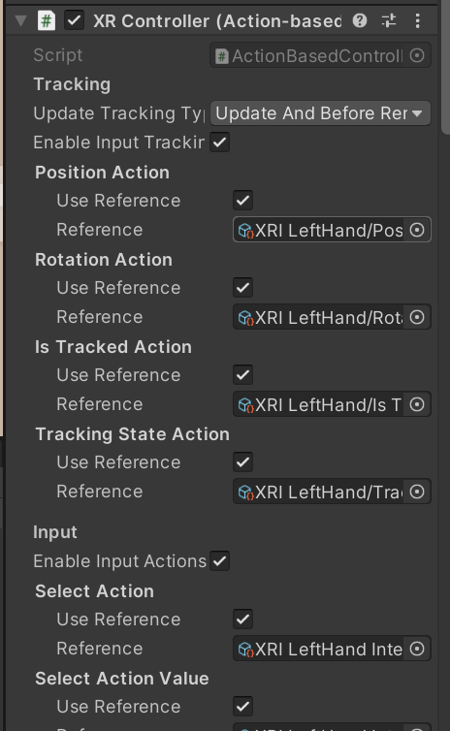

**Task 2: Create the Ground Plane and add a Skybox**

* I created this plane for my classroom setup.
* Then I add the below skybox which I downloaded from unity assets store.

<https://assetstore.unity.com/packages/2d/textures-materials/sky/free-stylized-skybox-212257>

this is the link from where I downloaded the skybox.

**Task 3: Add Environment Objects**

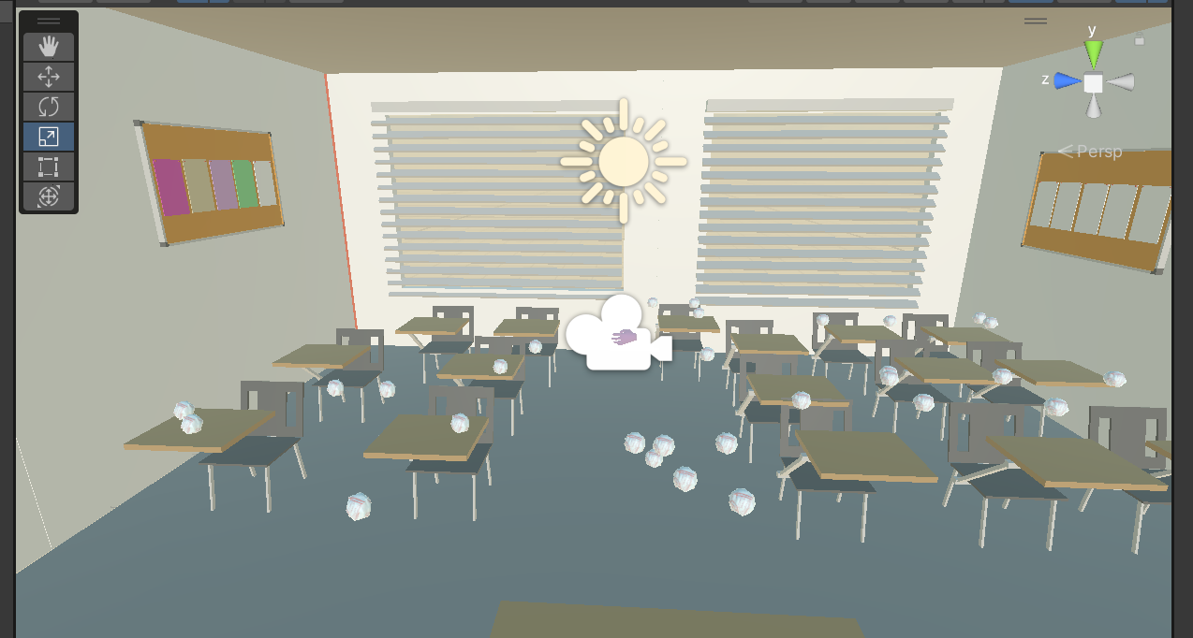

* I’m using school class room asset for this room and there are many small small paper ball are my grabbable objects.

<https://assetstore.unity.com/packages/3d/environments/school-assets-146253>

* The above link is the asset of school.
* After that I used paper ball to grab and throw at dustbin.
* This paper balls are grabbable objects and placed at different places.

**Task 4: Configure Lighting and Shadows**

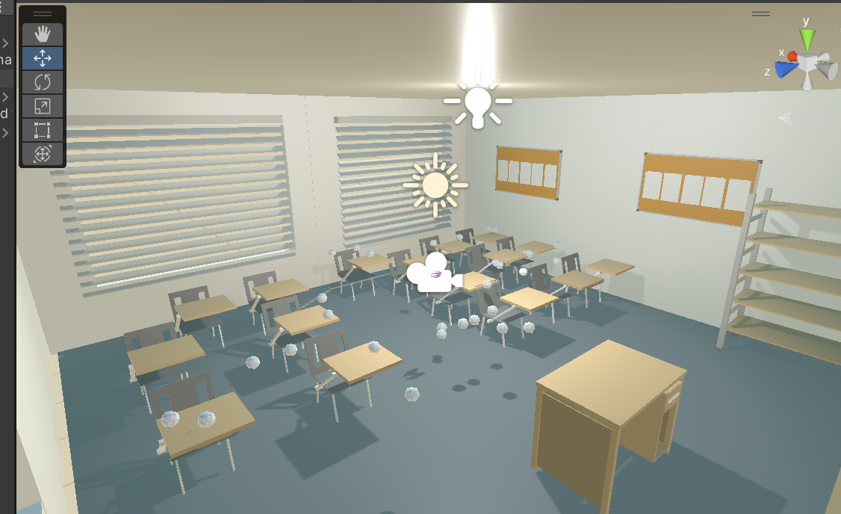

* in this task I added point light 
* and in that I selected soft shadow for smooth effect and I place this light at above and centre of the roof.
* this is the configuration I used,

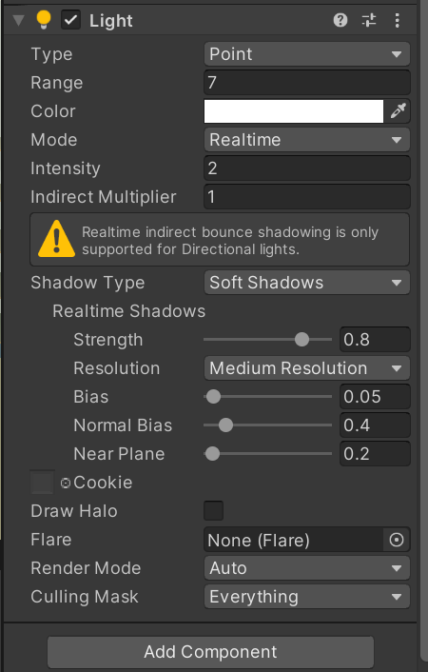

**Task 5: Add Audio**

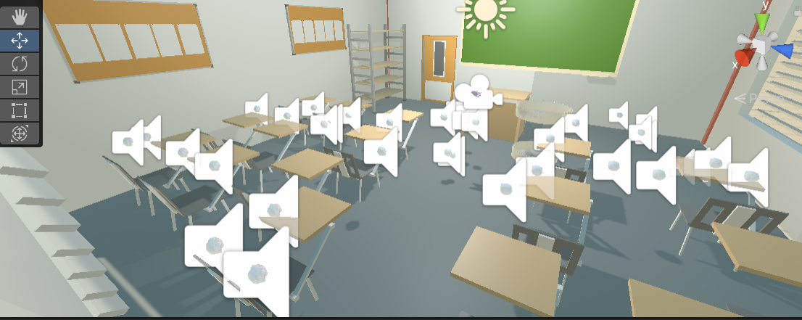

* I wrote one script and add sound for paper when it touches the dustbin or go inside the dustbin.
* Two different sounds I used for knowing that my ball is just touching the dustbin, or the ball went inside the dustbin.
* I add that script to all the paper balls and attach sound to them.

**Task 6: Implement Basic VR Interaction**

**In this task I imported one hand object to grab things**

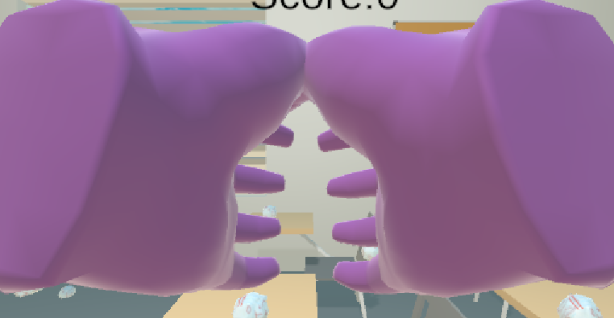

<https://drive.google.com/file/d/10b39IekUdpBHlcTslZ-BlNRyH5uqPUe1/view>

* From this link I downloaded the hands and then import it to unity.

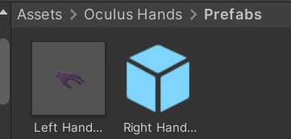

* Then I drag it to the controllers accordingly.

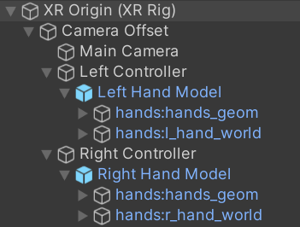

* After selecting both hands, in the inspector menu I change the shader to the standard mode so that arms look like normal, and I set the colours. First it looks like pink so that’s why I change it to standard.

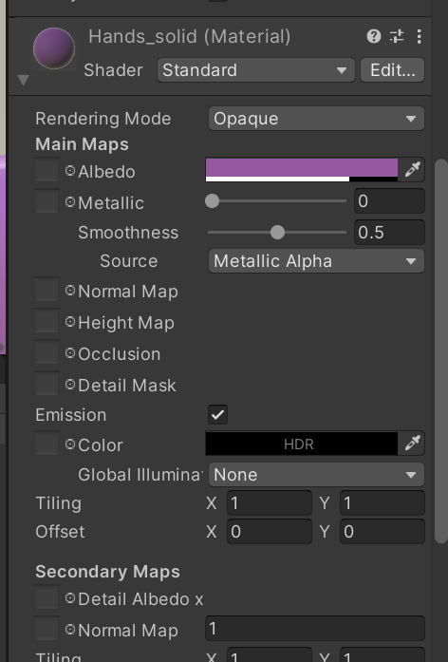

* After then I added one sphere collider to both the arms and set the trigger tick.
* By this I can grab the things which has XR grabbable component.
* Then I add XR grab interaction component to all the paper ball to make them grabbable

* That’s it by doing this only you can grab that paper ball and ready to throw it on the trash bin.
* I set the trash bin in a way that my paper ball cannot go directly through the bin it should go from the above space.
* I did this

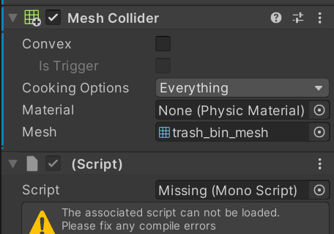

**Task 7: Write the VR Interaction Script**

* I wrote total of three VR interaction script to make it more user friendly.
* First script for the grab and pinch animation

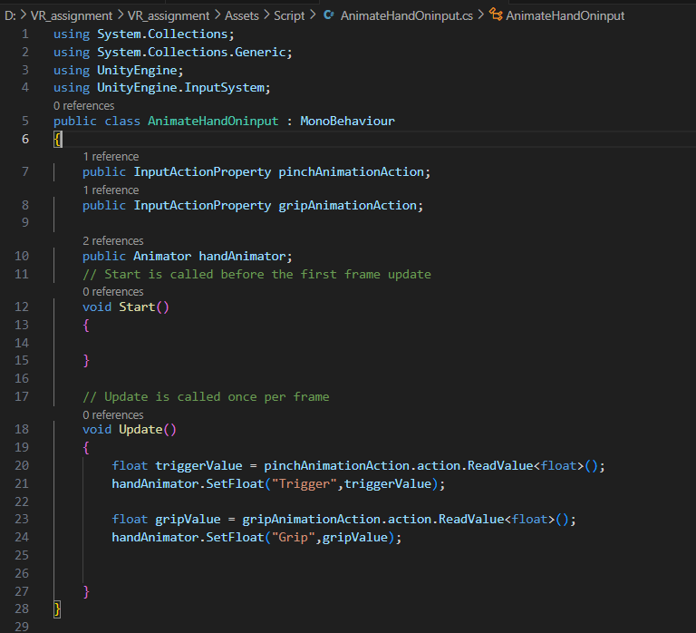

* Second for sound

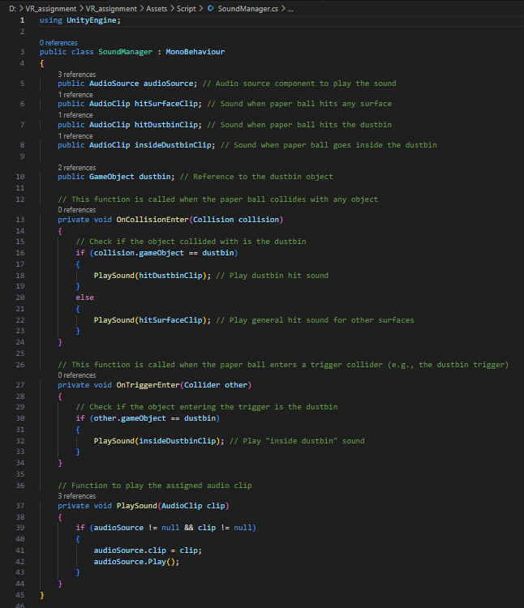

* And the last one for added the scoring mechanism.

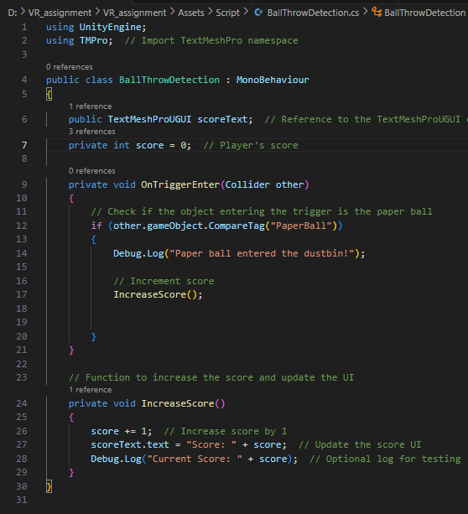

* So, these are the script I created for my VR project.

**Task 8: Create a scoring mechanism**

* For the scoring mechanism I created one script and added to the sphere object I created inside my trash bin.

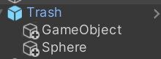

* In that sphere I added on sphere collider and that script of scoring
* Also I make this sphere look transparent because I don’t want that inside my trash bin one big round is visible.
* The reason behind creating this sphere is because first I attach the script to the bin but when I throw the paper ball and it touch the outer surface of the bin the score still counts and I don’t want that.
* Then I place this sphere at the bottom centre of the bin so when I throw inside the bin then only my score will increase.

* For the score visibility I created one TMP(Text Mesh Pro) and I write the simple Score text and then I attach that TMP to the script which I added to the sphere

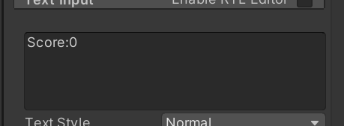

So in starting my score is 0 then it will increase by 1 point every time I throw the ball.

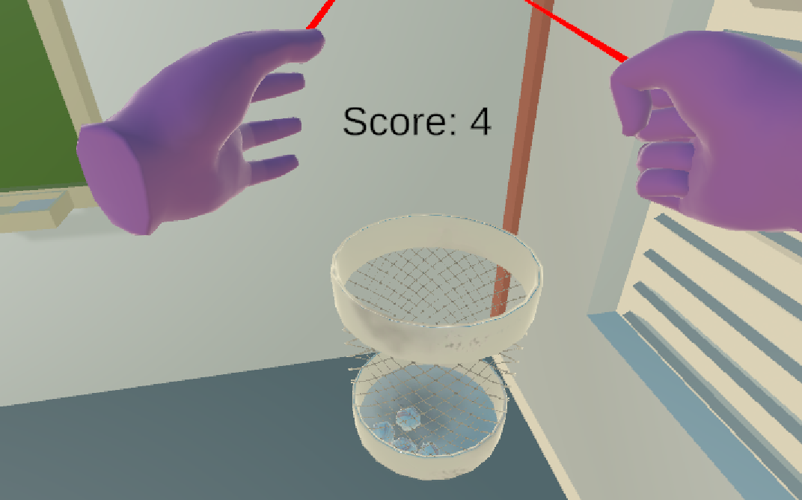

That’s it.

I completed all the task and keep it simple.

The only challenge I face in task 8 only. Thank you.